**SMART WATER FOUNTAINS**

**IoT - PHASE - 2**

**INNOVATIVE DESIGN**

**Objective :**

* Maintain Water Quality
* Leakage Detection
* Flow Control

**Keywords :**

Water Supply System , IOT , Water Level Sensor , Flow Sensor , Turbidity Sensor , Raspberry Pi , Arduino Nano , GSM.

**Sensors Requirement :**

* **Flow Sensor :**

Water flow sensor consists of a plastic valve body with a water rotor it uses a pinwheel sensor to measure how much liquid has moved through, water flows through the rotor rolls, speed changes which outputs the corresponding pulse Signal.

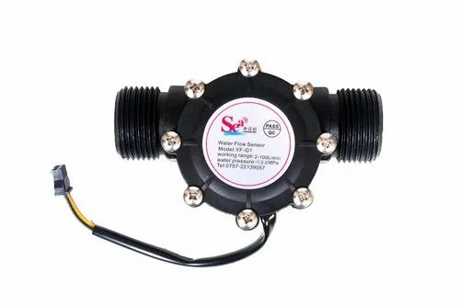

* **Turbidity Sensor :**

Turbidity sensor measure the amount of suspended particles, or turbidity in the water. If the Soil level increases transmitted light decreases Turbidity sensors are used to check quality of water.

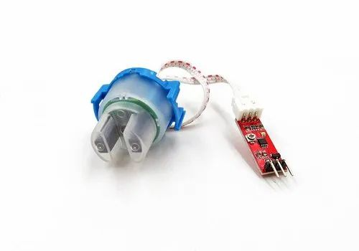

* **Level Sensor :**

Level sensor using ultrasonic waves fall into this category. It measure the liquid level based on the time the ultrasonic wave take to strike and return from the liquid surface

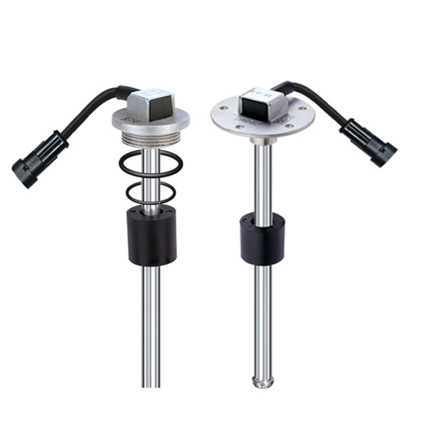

**Hardware Requirements :**

* **Arduino Nano :**

The Arduino Nano is a microcontroller board based on the ATmega328 it is a 8 bit microcontroller has 14 digital input/output pins (of which 6 can be used as PWM outputs).

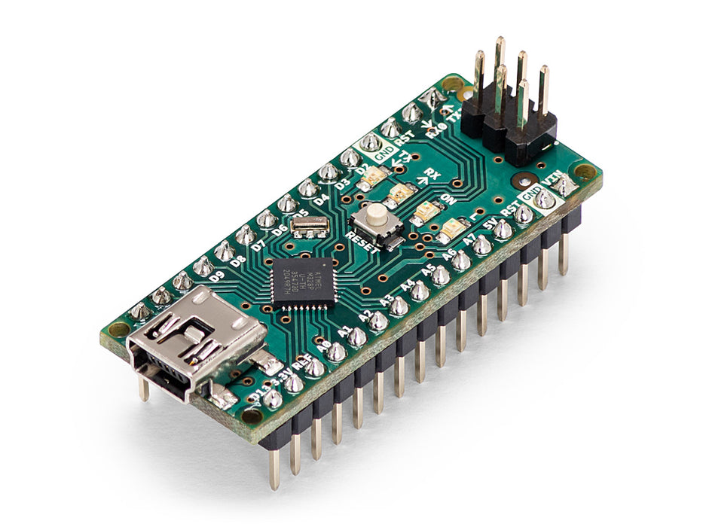

* **Solenoid valve :**

Solenoid valve is a electromechanically operated valve. Solenoid valve also known as an electrically operated valve is an automatic valve which serves the purpose of removing manual handling. These valves are used at pipeline to supply water with automatic ON off control. We can automatically operate valves and supply water when it is needed it reduces manual work.

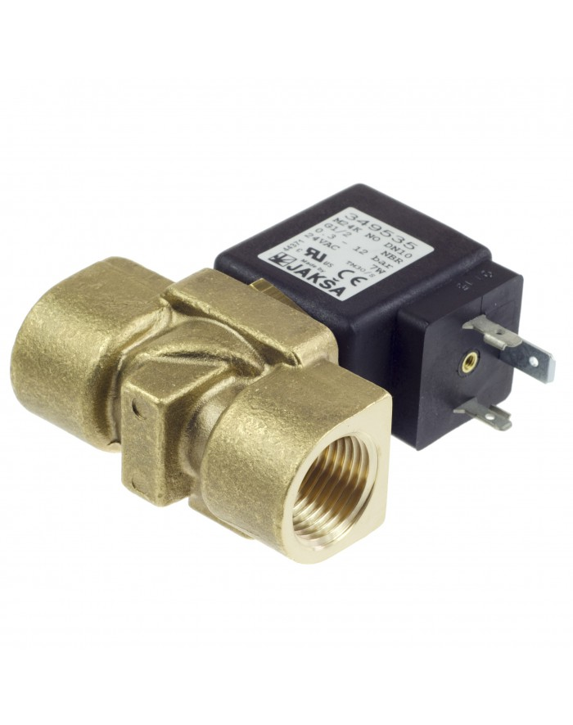

* **GSM :**

GSM (Global System for Mobile communications) is a cellular network, operate in the 900 MHz or 1800 MHz bands. Here GSM is used to trigger a message when there is no water in line or if there is abnormality or theft occurred in water supply line.

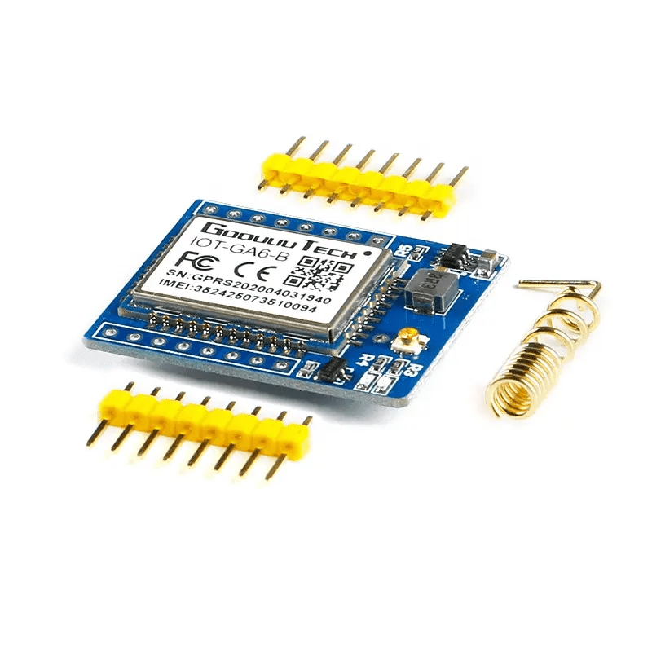

**Raspberry pi :**

Purpose of using raspberry pi in an IOT. Raspberry is compatible with IOT. All the data collected from arduino is connected with a raspberry pi and it process continuously and push data on cloud.

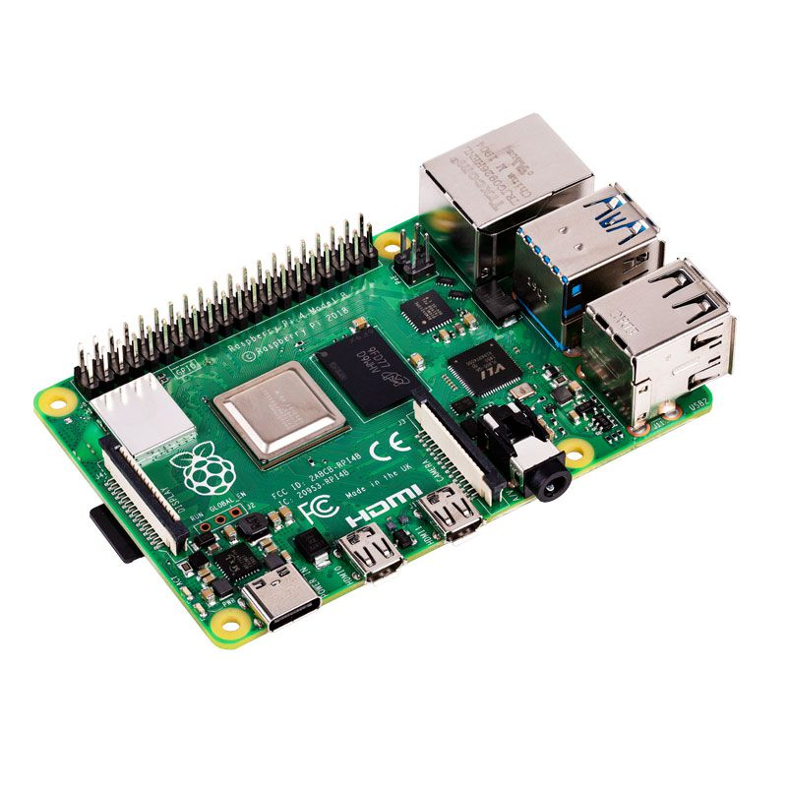

**System Design :**

System consists of Raspberry pi, Arduino, level sensor, flow sensor, turbidity sensor, GSM module each block is explained

All the above mentioned sensors and hardware components are used in Smart Water Fountains along with raspberry pi.

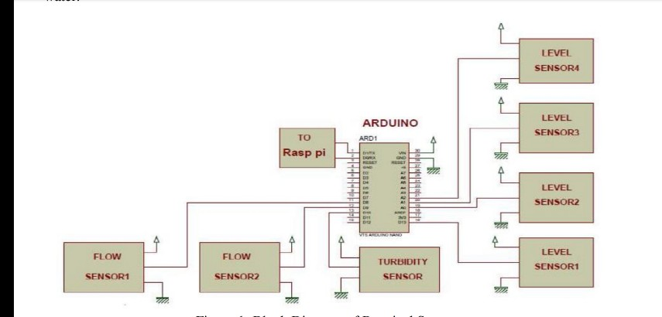

**Block Diagram**

**References**

Ejiofor V., Oladipo O., Microcontroller based automatic water level control system, International Journal of Innovative Research in Computer and Communication Engineering, Vol. 1, Issue 6, August 2013, 1390-1396.

Kumura T., Suzuki N., Takahashi M., Tominaga S., Morioka S., Ivan S., Smart water management technology with intelligent sensing and ICT for the integrated water systems, NEC Technical Journal, Vol. 9, No. 1, January, 2015, 103-106.